Manila Water CompanyCustomer NameDocument Title

FUNCTIONAL SPECIFICATION – Report

DID_M2C_056

Enhancement for Group Accounts Invoice Summary
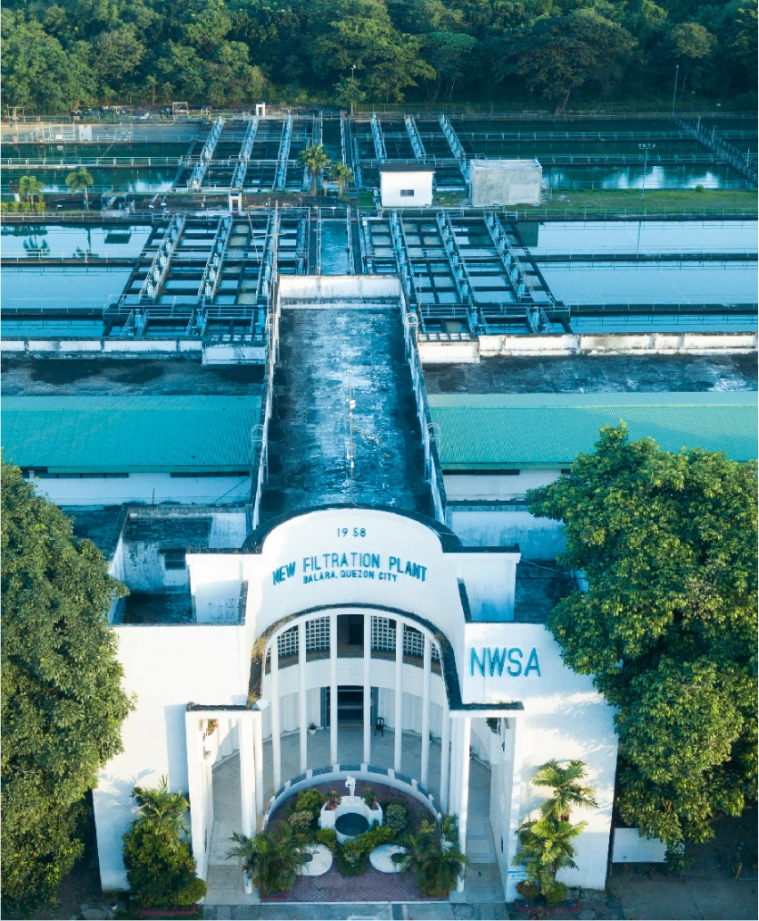





Contents
1 Document Organization 4
1.1 Document Log 4
1.2 Integration, Document Reference 4
2 Justification 5
3 Functional Description 5
4 Security / Authorization Requirements 5
4.1 Definition 5
4.2 Defined Fields 5
4.3 Procedure 5
5 Dependencies / Constraints 5
6 Assumptions 5
7 Security Requirements 5
8 Functional Requirement 6
8.1 Flow of Enhancement 6
8.2 Layout 6
9 Assumptions in Functional Design 6
10 Open Issues in Functional Design 6
11 Business Test Conditions 6
12 Related Documentation 6

Document Organization
This section provides details about this document, previous version(s) of this document and the document(s) referred.

Document Log
Following table mentions the version changes and the processer(s):
Version | Status | Date | Version Created by (Name/E-Mail/Company) | Role | Comments
0.1 | Draft | February 5, 2025 | Harshvardhan Rathore | Author | Draft for enhancement for Group Account Invoice Summary
0.2 | Ready for Review | February 6, 2025 | Roopali Sharma  roopali.sharma02@sap.com  Mohanrangan  mohanrangan.rangarajan@sap.com | Reviewer | Technical Review

Integration, Document Reference

Following documents are
S. No. | Referred Document Name | Referred Document Version | Referred Document URL (Optional)
1 | MWC_SDD_BI_02 Bill Correction and Monitoring and Collective Billing V4.0 | Version 4.0

The documents listed here are explicitly not part of this Functional Specification. They are not automatically accepted together with this Specification but may be subject to a separate customer/SAP acceptance.

Justification
SAP will have a manually executable program created to provide a summary grouped for a head group Business Partner which will display charges, meter readings and amount for each account under that group.

Functional Description
This Enhancement will validate the business conditions that are required while generating a Summary of the associated Account Invoice. The Business master data in SAP system will be required to be maintained in a particular (later specified) manner.
The Enhancement program will include a selection screen with two primary key input requirement, Group BP number & Bill Period.
The Output of the program would display
All Contract Accounts Grouped together will be considered based on the Contract Account Field “Alternate bill recipient” updated with a Group BP number. This Specified BP at the Contract Account level will work as an anchor for grouping.
This Group BP will be an independent BP without any contract account. It can have a field that can be utilized to have easier identification and is not mistaken as an unutilized business partner.
BUT0ID- TYPE = BPGRP & BUT0ID-IDNUMBER = “Group Name” (suggested name = BPGRP. This needs to be confirmed with Master Data Management Team before finalization)
The Program will Generate a summarized report with charges from all associated BO which are invoiced on the date of summary generation.
The output screen will be an ALV output grid and once user is confirms the detailed list, It can be downloaded using an excel button 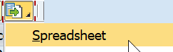

Security / Authorization Requirements
N/A

Definition
The purpose of this enhancement is to provide a custom program which would have a Group Business Partner along with Bill Period which will follow the principle to capture all associated contract accounts billed under the End BILL Date Range will be considered for generation of a Summary report. The report will be created with variation in output columns according to the company code.

Defined Fields
Field(s) for Selection Screen
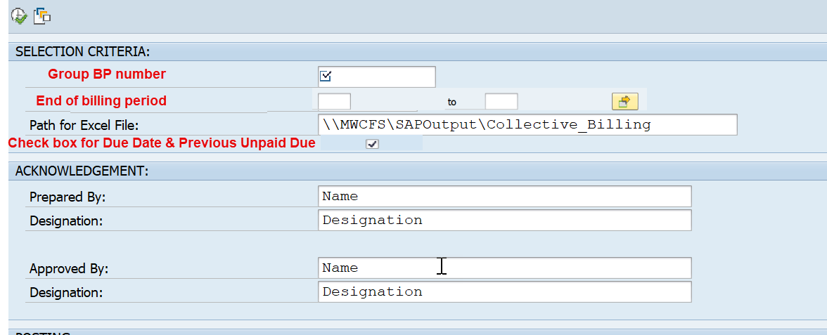
***There is proposal to add only the End Bill Period on the selection screen to validate the GT33 scenarios billed within the period and Moved out account (future possibility). [Reference: t-code: Z*_BILLREG is Bill Registry Program currently used by MWC follows same Date range input]
*** Business requirement to provide check box for “PREVIOUS UNPAID AMOUNT” and “DUE DATE”. If this check box is not selected, we will not show these two columns on the Non-East Zone format.
Business Partner :
This BP must have an identifier say, BPGRP ( “BUT0ID-TYPE = BPGRP)
Note: Only those contract account(s) with same BP maintained at field “Alt. bill rec”. FKKVKP-ABWRH will be considered)

Bill Period : End Bill Period Date Range on input screen (Date range for ERCH- ENDABRPE)
The Logic to determine Billing docs should be as below:-
End Bill Date-Start of date range on input screen>= ERCH- ENDABRPE of all eligible bill docs>= End Bill Date-End of date range on input screen

Note: The range given by the user should only be the dates of last day of the bill generated.

Download Path for Excel: \\ MWCFS \ SAP Output \ Group Invoice Summary\ Name the file.
** The Acknowledgement section is to be kept on the selection screen but it is not mandatory to be filled.
Name of user Preparing : Text field for name ( editable field on selection screen)
Designation : Text field for Designation ( editable field on selection screen)

Approved By: Text field for name (editable field on selection screen)
Designation : Text field for Designation (editable field on selection screen)

Master Data Maintenance field:
This field must be maintained with a Group BP created only to be the head of the master data for all the associated contract account; to be updated at the following field with the said Group BP.
Alternate bill recipient. = FKKVKP – ABWRH ( mandatory to be maintained at Business Master data)

Output View:
The output here would be an ALV grid display with option to delete any row considered by the user in the generated output..
It is required to have an Excel save button required to prepare and save the excel on the path provided on the selection screen.
The generated Excel is required to have for additional field with the same information provided on the Acknowledgment section of the selection screen.
There should be an option to convert and generate PDF as well.

Procedure
The Program is expected to generate a summarized report based on charges from bill document of each associated account.
The selection screen will have two primary key input fields - Group BP number and Bill Month.
Once the inputs are provided, the program is expected to fetch all the contract accounts which has been maintained by updating field “Alternate bill recipient” (FKKVKP – ABWRH), with the same BP number as the Group BP number.
The Program then would take the Bill date range from selection input screen and provide VKONT(FKKVKP_VKONT) to enter ERCH and get value for BELNR with conditions STORNODAT = blank, SIMULATION= blank, BELEGART = VA or SA, TOBRELEASD = blank, LOEVM = blank, BCREASON= blank, NBILLREL = blank and Input screen Billing date range start value is >=(GE) to ERCH- BEGABRPE and Also Billing end Date from selection screen is <=(LE) ERCH- ENDABRPE

Using the BELNR, enter table ERCHC with conditions TOBRELEASD = blank, SIMULATED= blank, INTCPUDT = blank. Select Invoice Doc (OPBEL).
Enter Table ERDK with OPBEL and Program would select for all the contract accounts which are not reversed (STOKZ = blank), not simulated (SIMULATED=blank), released (TOBRELEASD = X) with Billing transaction (ABRVORG = 01or02or03)and Creation Reason(ERGRD=01). Select all Print Docs (OPBEL) and respective accounts(VKONT)
.
Now that program has respective valid Invoicing & Billing document for each contract account following the logic till now, then program logic would fetch required charges, meter readings and amounts from the billing document which is provided in the technical description & attached Layout excel in Technical Requirement Section 8.2

Dependencies / Constraints
- The “Group BP” can be maintained with a custom Identification (say BPGRP) to have a clearer identification.
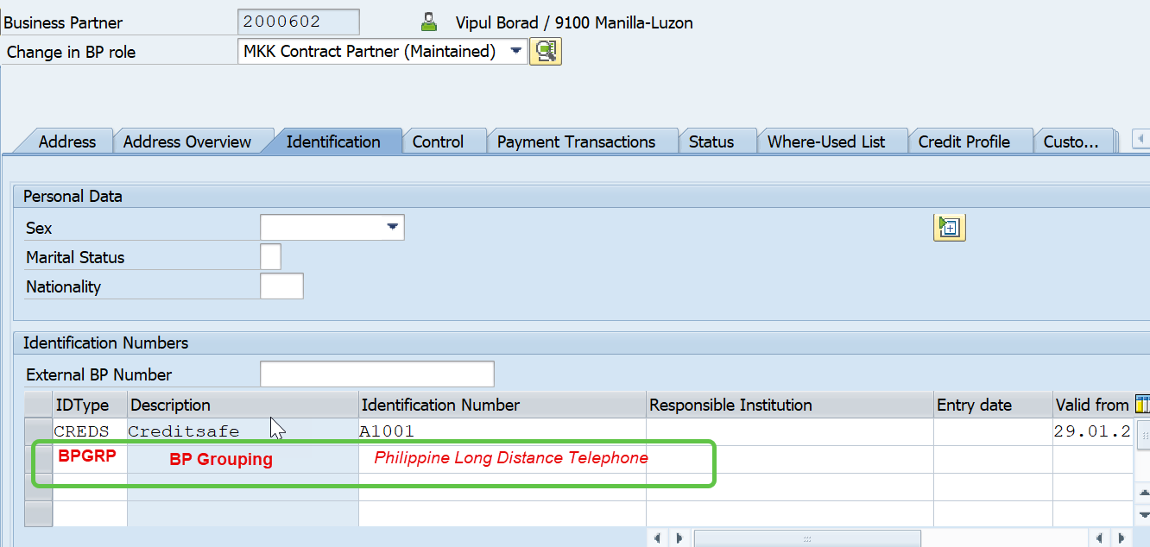
- The Contract Account to be selected under one group must be maintained with Group BP number at the FKKVKP- ABWRH. 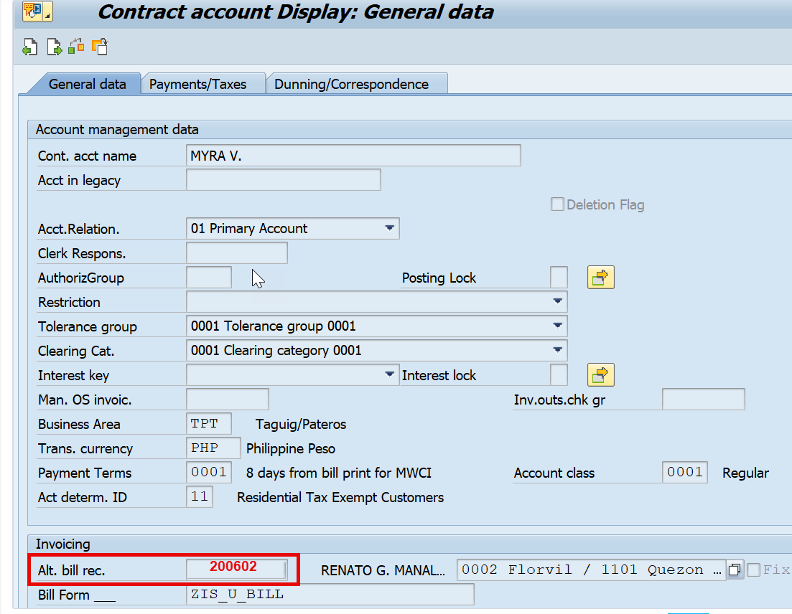

- A representation of how account would be grouped is as below:-
Associated Account | Business Partner | Alt Bill Recipient | Identification | Identification number
10640522 | 66469 | 2000602 | BPGRP | Phillipine Long Distance Telephone
10648365 | 67292 | 2000602 | BPGRP | Phillipine Long Distance Telephone
10687919 | 71691 | 2000602 | BPGRP | Phillipine Long Distance Telephone
10687964 | 71696 | 2000602 | BPGRP | Phillipine Long Distance Telephone
10718761 | 74779 | 2000602 | BPGRP | Phillipine Long Distance Telephone
10722612 | 75182 | 2000602 | BPGRP | Phillipine Long Distance Telephone
10735207 | 76442 | 2000602 | BPGRP | Phillipine Long Distance Telephone
10736625 | 76587 | 2000602 | BPGRP | Phillipine Long Distance Telephone
10737535 | 76683 | 2000602 | BPGRP | Phillipine Long Distance Telephone
10738605 | 76789 | 2000602 | BPGRP | Phillipine Long Distance Telephone
10757246 | 78726 | 2000602 | BPGRP | Phillipine Long Distance Telephone
11716182 | 187870 | 2000602 | BPGRP | Phillipine Long Distance Telephone
13558660 | 352246 | 2000602 | BPGRP | Phillipine Long Distance Telephone
14324260 | 485910 | 2000602 | BPGRP | Phillipine Long Distance Telephone
15122289 | 563495 | 2000602 | BPGRP | Phillipine Long Distance Telephone
18156718 | 842836 | 2000602 | BPGRP | Phillipine Long Distance Telephone
18847508 | 911165 | 2000602 | BPGRP | Phillipine Long Distance Telephone
10646713 | 67118 | 2100211 | BPGRP | SOCIAL SECURITY SYSTEM 1
10699372 | 72835 | 2100211 | BPGRP | SOCIAL SECURITY SYSTEM 1
11191961 | 120843 | 2100211 | BPGRP | SOCIAL SECURITY SYSTEM 1
13279114 | 341810 | 2100211 | BPGRP | SOCIAL SECURITY SYSTEM 1
13546576 | 360026 | 2100211 | BPGRP | SOCIAL SECURITY SYSTEM 1
14589723 | 512802 | 2100211 | BPGRP | SOCIAL SECURITY SYSTEM 1
14589741 | 512804 | 2100211 | BPGRP | SOCIAL SECURITY SYSTEM 1
16369403 | 675887 | 2100211 | BPGRP | SOCIAL SECURITY SYSTEM 1
19988569 | 1021572 | 2100211 | BPGRP | SOCIAL SECURITY SYSTEM 1
19988603 | 1021585 | 2100211 | BPGRP | SOCIAL SECURITY SYSTEM 1
19988612 | 1021586 | 2100211 | BPGRP | SOCIAL SECURITY SYSTEM 1
19988621 | 1021587 | 2100211 | BPGRP | SOCIAL SECURITY SYSTEM 1
10143436 | 14314 | 2523872 | BPGRP | GOLDEN ARCHES DEVT CORP (McDO) 2
13300180 | 331939 | 2523872 | BPGRP | GOLDEN ARCHES DEVT CORP (McDO) 2
14299289 | 483386 | 2523872 | BPGRP | GOLDEN ARCHES DEVT CORP (McDO) 2
15138450 | 564812 | 2523872 | BPGRP | GOLDEN ARCHES DEVT CORP (McDO) 2
19055745 | 931359 | 2523872 | BPGRP | GOLDEN ARCHES DEVT CORP (McDO) 2
19396501 | 964045 | 2523872 | BPGRP | GOLDEN ARCHES DEVT CORP (McDO) 2
19823274 | 1005482 | 2523872 | BPGRP | GOLDEN ARCHES DEVT CORP (McDO) 2
20606890 | 1081864 | 2523872 | BPGRP | GOLDEN ARCHES DEVT CORP (McDO) 2

- The Program is designed to be executed manually for one group BP at a time to generate the summary report for all associated accounts.

Assumptions
- The User is aware of the Master Data set up where Group Business Partner number and Contract Account are linked together accurately. The Expected Scheduled Billing date for the account should come to attempt to execute on or after the date itself.
- All active Contracts in a particular Contract Account will be considered in the Display Report.

Security Requirements
NA

Functional Requirement
The Group Account Invoiced Summary in Manila Water Company Requires to be summarized for all the associated Contract Accounts Invoiced at the time of execution of the program, for that Billing Period.
This custom transaction can be used by the authorized user to be executed once the Scheduled Billing date of the associated accounts has been reached. The User is required to specify MM/YYYY on the selection screen and should execute the program after providing the Name & Authorized Designation.

The program will process either the Business Partner or ID group Identification Number from the selection screen and then identify all the accounts falling under the same Bill Key Date. Once all the associated accounts according to the scheduled billing date identified.
In case associated invoices for the same scheduled billing date are billed, the program then processes all Invoices further to get different charges from each bill that have been created and generate a summarized report for Parent Account.
The account summary is expected to contain following values in the below format:
Table 1: East Zone Summary format
CONTRACT ACCOUNT NUMBER | B.A. | RATE CLASS | Meter No. | BILLING PERIOD | PREVIOU READING | CURRENT READING | ACTUAL CONS. CU.M | TOTAL VARIABLE CURRENT CHARGE ( Water Charge Minus the Governement tax) | % Govt Tax ( Same as LFT + NFT) | TOTAL AMOUNT DUE | 2% CWT ( posted by custom program) | AMOUNT OF NET OF TAX WITHHELD
10640522 | BAL | COM01 | Need to indicate | 05FEB2024-05MAR2024 | 4344 | 4525 | 181 | 18,099.60 | 475.48 | 18,575.08 | 361.99 | 18,213.08
10648365 | CUB | COM01 | Consumption meters only | 03FEB2024-03APR2024 | 2266 | 2372 | 106 | 10,578.66 | 277.90 | 10,856.56 | 211.57 | 10,644.99
10648365 | CUB | COM01 | Consumption meters only | 03FEB2024-03APR2024 | 2643 | 2 | 106 | 10,578.66 | 277.90 | 10,856.56 | 211.57 | 10,644.99
10687919 | MAK | COM02 |  | 01FEB2024-01MAR2024 | 3171 | 5157 | 1986 | 2,58,174.14 | 6454.35 | 2,64,628.49 | 5163.48 | 2,59,465.01
10687964 | MAK | COM02 |  | 01FEB2024-01MAR2024 | 486689 | 489912 | 3223 | 4,23,380.70 | 10584.52 | 4,33,965.22 | 8467.61 | 4,25,497.60
10718761 | SJM | COM01 |  | 01FEB2024-01MAR2024 | 43770 | 44433 | 663 | 66,896.40 | 1672.41 | 68,568.81 | 1337.93 | 67,230.88
10722612 | SJM | COM01 |  | 01FEB2024-01MAR2024 | 278727 | 280571 | 1844 | 1,89,519.29 | 4737.98 | 1,94,257.27 | 3790.39 | 1,90,466.89
10735207 | MAR | COM01 |  | 01FEB2024-01MAR2024 | 380 | 412 | 32 | 3,192.14 | 87.78 | 3,279.92 | 63.84 | 3,216.08
10736625 | SJM | COM01 |  | 05FEB2024-05MAR2024 | 70450 | 71153 | 703 | 70,981.74 | 1810.03 | 72,791.77 | 1419.63 | 71,372.14
10737535 | SJM | COM01 |  | 02FEB2024-02MAR2024 | 93526 | 93837 | 311 | 31,177.66 | 795.03 | 31,972.69 | 623.55 | 31,349.14
10738605 | PAS | COM01 |  | 04FEB2024-04MAR2024 | 10909 | 10944 | 35 | 3,492.85 | 89.07 | 3,581.92 | 69.86 | 3,512.06
10757246 | SJM | COM01 |  | 21FEB2024-01MAR2024 | 8 | 24 | 43 | 4,293.75 | 112.80 | 4,406.55 | 85.88 | 4,320.67
11716182 | MAK | COM02 |  | 03FEB2024-03MAR2024 | 7353 | 7378 | 25 | 3,149.00 | 82.72 | 3,231.72 | 62.98 | 3,168.74
13558660 | SJM | COM01 |  | 08FEB2024-08MAR2024 | 1323 | 1968 | 645 | 65,061.73 | 1659.07 | 66,720.80 | 1301.23 | 65,419.57
14324260 | RIZ | COM01 |  | 01FEB2024-01MAR2024 | 7925 | 7974 | 49 | 4,888.18 | 122.20 | 5,010.38 | 97.76 | 4,912.62
15122289 | PAS | COM01 |  | 07FEB2024-07MAR2024 | 640 | 701 | 61 | 6,085.03 | 152.13 | 6,237.16 | 121.70 | 6,115.46
18156718 | RIZ | COM01 |  | 01FEB2024-01MAR2024 | 28431 | 29329 | 898 | 91,012.86 | 2502.85 | 93,515.71 | 1820.26 | 91,695.46
18847508 | PAS | COM01 |  | 09FEB2024-09MAR2024 | 637 | 639 | 2 | 997.91 | 24.95 | 1,022.86 | 19.96 | 1,002.90

Flow of Enhancement

Figure 1Program flow to generate summary report
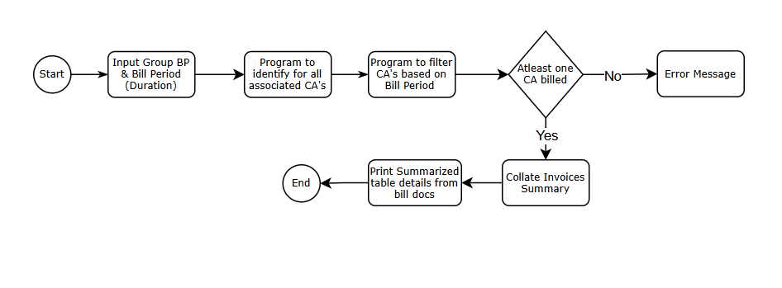

Technical Requirement
This section is only to guide the technical consultant as to how the approach should be taken while designing the program.
- The program should create a summary report of charges related to all Accounts associated at the Business Partner Identification.
- Below Charges for each accounts are calculated and displayed:-
  - Previous Consumption
  - Actual Consumption :(dberchz1-v_abrmenge)
    - zprev LIKE eabl-adatsoll,
* zprev_reading LIKE eabld-consmpt,
zprev_reading LIKE dberchz1-v_abrmenge,
zcurr LIKE eabl-adatsoll,
* zcurr_reading LIKE eabld-consmpt,
zcurr_reading LIKE dberchz1-v_abrmenge,

  - Prev Balance : (Sum up all ACCINF line item amount.)
  - BASIC : ( dberchz3-nettobtr for dberchz1-belzart = ZBASIC)
  - FCDA : (dberchz3-nettobtr for dberchz1-belzart = ZFCDA)
  - ENV : ( dberchz3-nettobtr for dberchz1-belzart = ZENV)
  - SEWER : ( dberchz3-nettobtr for dberchz1-belzart = ZSEWER)
  - MSC : ( dberchz3-nettobtr for dberchz1-belzart = ZMSC)
  - Other Charges : (dberchz3-nettobtr for dberchz1-belzart = pending)
  - CURRENT BEFORE TAXES ( dberchz3-nettobtr)
  - VAT : (dberchz3-nettobtr with ZVAT)
  - TOTAL : (dberchz3-nettobtr_Total)
  - Due Amount : ERDK - NETOBTR

- There are multiple Charges displayed based on Main-Sub configuration - Direct AR Computation, If instalment within cutoff date , If date is less than cutoff date
  - If PDF requirement is confirmed by the user, using FM “ CONVERT_OTF_2_PDF”, for generating PDF.
  - It also generates an Excel file for review as there is an error message - MESSAGE e208(00) WITH 'ERROR IN DOWNLOADING EXCEL FILE!'.

- For exempted tax calculation, we should refer to existing custom Program ZMWC_COLLECTIVE_INVOICE
- Check for Tax exemption using kofiz = 11,21, 31, 41 are all tax exempted
  - 2percent tax without vat
  - 5percent tax without vat
  - city tax without vat
- Check for VAT
  - 2percent tax with vat
  - 5percent tax with vat
  - city tax with vat
  - city tax always gross
  - vatable amount
  - 12% VAT
- Get the Bill period for Current and Previous value
  - 01 – JAN, 02 – FEB…..12-Dec and concatenate according current and previous month display
Non – East Zone:-
Use ERDK to get VKONT and enter table FKKVKP using VKONT to get Value for company code.
Non East Zone Format to be followed, if the Company Code (FKKVKP- OPBUK) is not equal to MWCI or M001. Else the above mentioned format.

Table 2: Non-East Zone Summary format
 |  |  |  |  |  |  |  | BREAKDOWN OF CHARGES
ACCOUNT NO. | ACCOUNT NAME | ADDRESS | MRU | METER # | PREVIOUS READING | PRESENT READING | CONSUMPTION | Water Charge | Sewer Charge | Environmental Charge | Total Vatable Charge | 12% vat | FCDA Charge | TOTAL CURRENT CHARGE | PREVIOUS UNPAID AMOUNT | TOTAL AMOUNT DUE | DUE DATE
 |  |  |  | only consumption meters |  |  |  |  |  |  |  |  |  |  | Optional |  | Optional

Technical note: For Detailed version and logic for each field value extraction, please refer to the attached excel layout approved by the Business Team.
***Business requirement to add a delete button on the output ALV screen to delete any row on the ALV output screen before the Save Excel button is utilized.

Assumptions in Functional Design
- The Primary assumption for the entire process is to ensure that we have accounts grouped according to East Zone and Non-East Zone. It should never be a case that east zone account is grouped with a Non-east Zone account. There will be no check mechanism to verify and remove the other zone data, if inadvertently added to the Group BP.

Open Issues in Functional Design
- Non-East Zone customer require certain aspects to differ the East Zone customer
- East Zone Collective summary has a separate message text regarding Septic Sludge – MWC needs to confirm if this is required in future. – Confirmed by business that it is Not Required in the summary .
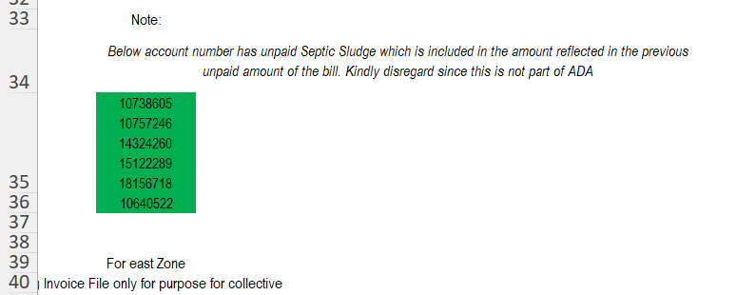
- List of all accounts to be grouped together under one group BP from East Zone & Non-East Zone.
- On East Zone Format, it is required to post 2% CWT posted by custom program currently. Please share if this 2% CWT will continue to be posted by custom program. Which custom program?

Business Test Conditions

Scenario # | Input Selection Criteria | Expected Result
1 | Provide Group BP with End Bill Date Range where None Account are billed for this month. | Program generates an error “None of the associated BP Billed yet”
2 | Provide Group BP with End Bill Date Range where a few BPs are billed for this month. | Program creates an invoice summary report
3 | Provide Group BP with End Bill Date Range where all Business Partner are all billed for this month. | Program creates an invoice summary report according to summary provided by East Zone
4 | Provide Group BP with End Bill Date Range where Associated CA Invoices are all billed for this month. Company code not equal to MWCI or M001 | Program creates an invoice summary report according to summary provided by Non East Zone
5 | Provide Group BP on selection screen where Identification doesnot exists | Generates an error message for invalid Business Partner.

Related Documentation

- Email Communication regarding query on Collective Invoice Group Account Invoice Summary
- Existing Program ZMWC_COLLECTIVE_ INVOICING can be Referred for summarization report.

